Department of CSE-IOT

Vision of the Department
To be a preferred hub for nurturing computer engineering aspirants through innovative, ethical, value-based technical education, impactful research, and industry collaboration, to become successful professionals contributing for the betterment of society.

Mission of the Department
To nurture computer engineering professionals by offering: Dynamic learning environment that encourages problem-solving using emerging technology, · National Education Policy aligned evidence-based technical education, fostering innovation, research, and industry–institute
collaboration, Holistic, ethical and sustainable development for lifelong success.

Session 2025-2026(EVEN)
Mission: Means to achieve Vision
Vision: Dream of where you want.
Program Educational Objectives of the program (PEO): (broad statements that describe the professional and career accomplishments)
PEO1 | Preparation | P: Preparation | Pep-CL abbreviation  pronounce as Pep-si-lL easy to recall
PEO2 | Core Competence | E: Environment (Learning Environment)
PEO3 | Breadth | P: Professionalism
PEO4 | Professionalism | C: Core Competence
PEO5 | Learning  Environment | L: Breadth (Learning in diverse areas)

Program Outcomes (PO): (statements that describe what a student should be able to do and know by the end of a program)

Keywords of POs:
Engineering knowledge, Problem analysis, Design/development of solutions, Conduct Investigations of Complex Problems, Engineering Tool Usage, The Engineer and The World, Ethics, Individual and Collaborative Team work, Communication, Project Management and Finance, Life-Long Learning

PSO Keywords: Cutting edge technologies, Research

“I am an engineer, and I know how to apply engineering knowledge to investigate, analyse and design solutions to complex problems using tools for entire world following all ethics in a collaborative way with proper management skills throughout my life.” to contribute to the development of cutting-edge technologies and Research.

Integrity: I will adhere to the Laboratory Code of Conduct and ethics in its entirety.

Anushka Yede

Name and Signature of Student and Date
(Signature and Date in Handwritten)

Department of CSE-IOT

Vision of the Department
To be a preferred hub for nurturing computer engineering aspirants through innovative, ethical, value-based technical education, impactful research, and industry collaboration, to become successful professionals contributing for the betterment of society.

Mission of the Department
To nurture computer engineering professionals by offering: Dynamic learning environment that encourages problem-solving using emerging technology, · National Education Policy aligned evidence-based technical education, fostering innovation, research, and industry–institute
collaboration, Holistic, ethical and sustainable development for lifelong success.

Session | 2024-25 (EVEN) | Course Name | Mobile and Web Application for IOT Lab
Semester | 6 | Course Code | 23IOT1624
Roll No | 01 | Name of Student | Anushka Yede

Practical Number | Practical no 1
Course Outcome | - Understand and apply basic Kotlin programming constructs including variables, control structures, functions, null safety, and object-oriented concepts for Android app development.  - Design and develop responsive user interfaces using XML layout files, ViewGroups, and widgets in Android Studio, adhering to Material Design principles.  - Implement event handling and application logic using Kotlin to capture user input, manage app state, navigate between screens, and interact with Android system components like Toasts and Dialogs  - Integrate learned concepts to develop a mini Android application that demonstrates use of ViewModel, multi-screen navigation, and proper UI/UX design for real-world problem- solving
Aim | Objective: Set up Kotlin development using Kotlin Playground and Android. Studio
Problem Definition | Write simple Kotlin programs using variables, data types, operators. - Practice control flow using if, when, for, and while.
Theory  (100 words) | Kotlin is a ultramodern, terse, and safe programming language developed by JetBrains. It's officially supported by Google for Android development and can also be used for web and desktop operations. Kotlin reduces boilerplate law compared to Java and helps help common crimes like null pointer exceptions. It supports introductory programming generalities similar as variables, data types, drivers, and control inflow statements. Control inflow tools like if, when, for, and while help a program make opinions and repeat tasks efficiently. Kotlin can be rehearsed fluently using Kotlin Playground or Android Studio.
Procedure and Execution  (100 Words) | Step for Implementation:  • Open Kotlin Playground (online) or install Android Studio.  • Create a new Kotlin file or project.  • Write a main() function as the program entry point.  • Declare variables using val (constant) and var (mutable).  • Use data types like Int, Double, Boolean, and String.  • Apply operators for calculations and comparisons.  • Implement control flow using if, when, for, and while.  • Run the program using the Run button to execute the code and view output.
Code:

- Kotlin playground

- Code 1

fun main() {
val number = 7

// if-else
if (number % 2 == 0) {
println("Even number")
} else {
println("Odd number")
}

// when statement
when (number) {
1 -> println("One")
2 -> println("Two")
in 3..10 -> println("Between 3 and 10")
else -> println("Other number")
}

// for loop
for (i in 1..5) {
print("$i ")
}
println()

// while loop
var count = 5
while (count > 0) {
print("$count ")
count--
}

}

Code 2

fun main() {
// Variables
val name: String = "Sadaf" // Immutable
var age: Int = 25 // Mutable

// Data Types
val percentage: Double = 87.5
val isPassed: Boolean = true

// Operators
val nextAge = age + 1
val marks = 450
val total = 500
val result = marks >= 200

println("Name: $name")
println("Age: $age")
println("Next Age: $nextAge")
println("Percentage: $percentage")
println("Passed: $isPassed")
println("Result: $result")

// Emoji example
val kotlin = "🙂"
println(kotlin)
}

Department of CSE-IOT

Vision of the Department
To be a preferred hub for nurturing computer engineering aspirants through innovative, ethical, value-based technical education, impactful research, and industry collaboration, to become successful professionals contributing for the betterment of society.

Mission of the Department
To nurture computer engineering professionals by offering: Dynamic learning environment that encourages problem-solving using emerging technology, · National Education Policy aligned evidence-based technical education, fostering innovation, research, and industry–institute
collaboration, Holistic, ethical and sustainable development for lifelong success.

Output:
Code 1

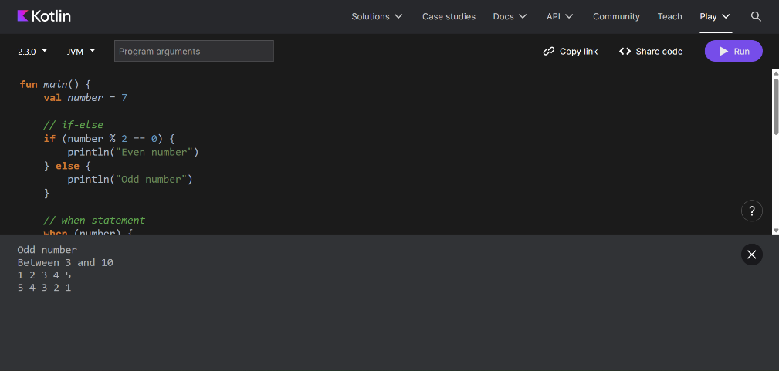

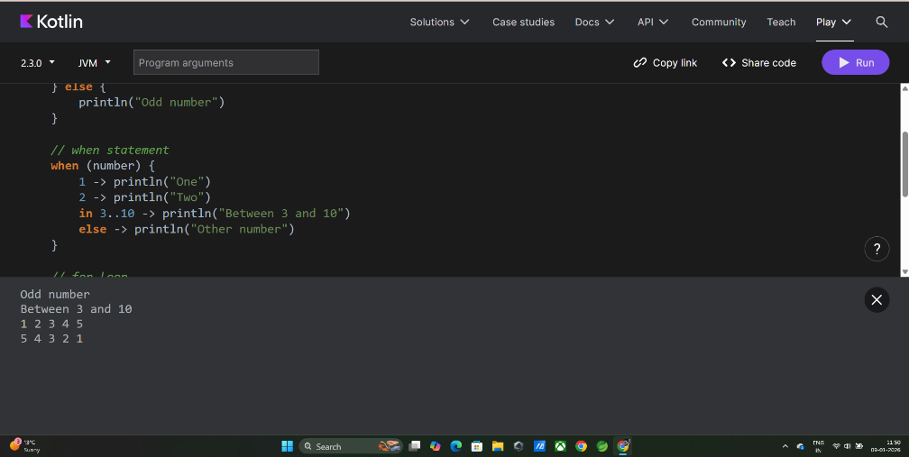

Code 2

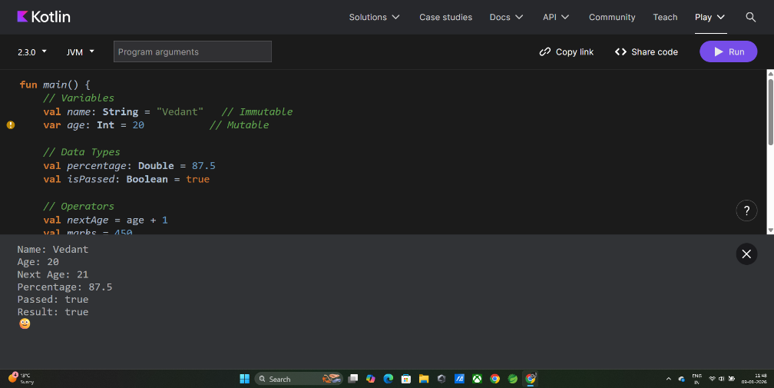

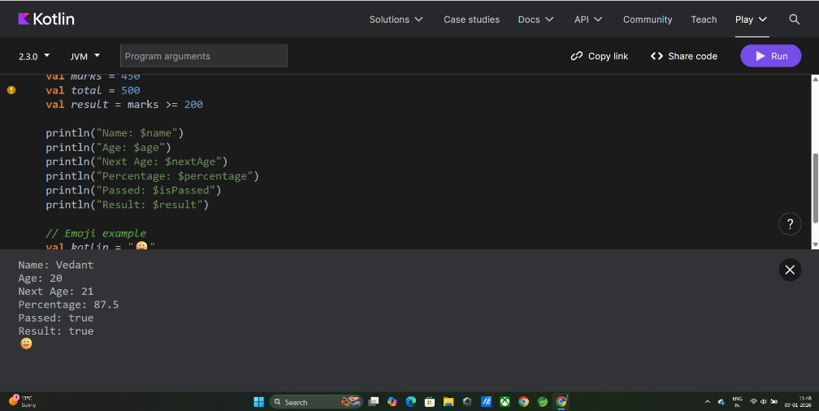2) Andriod Studio code
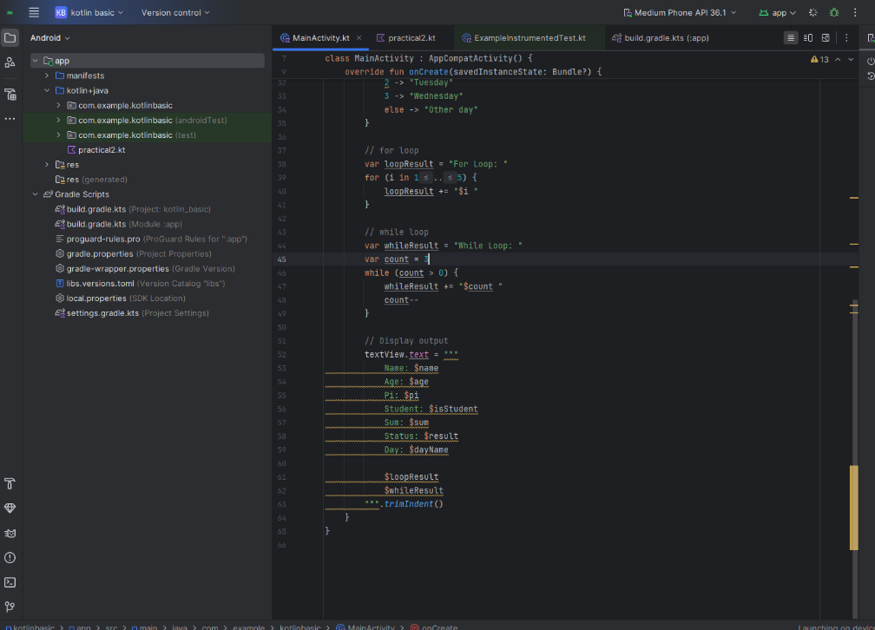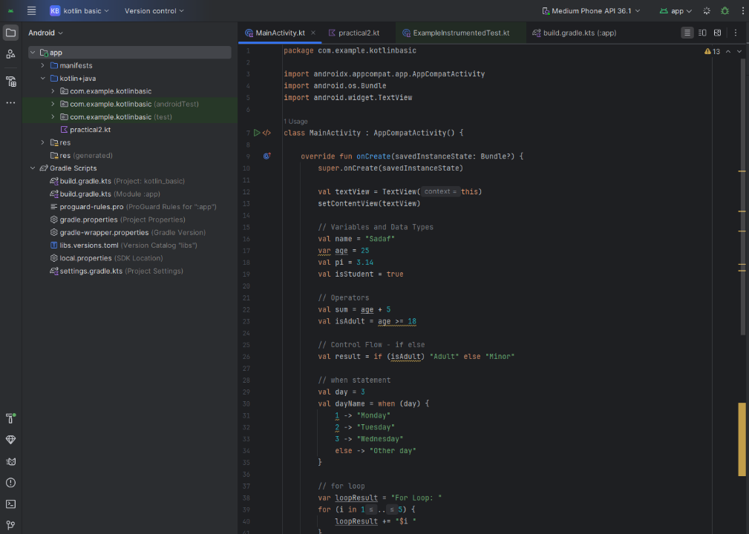
Output Analysis | The output displays results based on the logic written in the program. Conditional statements (if and when) decide which message is printed depending on the input value. Loops (for and while) repeatedly print numbers according to defined conditions. Correct outputs confirm that variables, operators, and control flow statements are working properly. Any incorrect output indicates logical or syntax errors that need correction.
Link of student Github profile where lab assignment has been uploaded | https://github.com/23071016/MWIOT-.git
Conclusion | Kotlin is easy to learn and beginner-friendly, making it ideal for new programmers. By practicing basic programs using variables, data types, operators, and control flow statements, learners gain a strong foundation in programming logic. Using tools like Kotlin Playground and Android Studio helps in quick testing and real-world application development. This experiment successfully demonstrates how Kotlin programs are written, executed, and analyzed.
Plag Report (Similarity index < 12%) | 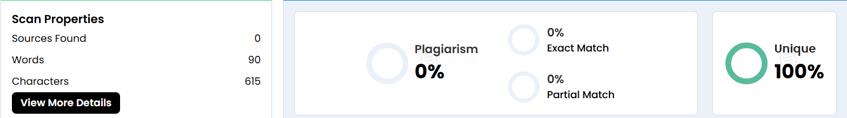
Date | 9/1/26

